End of Kapu Histagram Directions
Step One: Find twelve images/pictures that tell the entire story of the End of the Kapu
Step Two: For each picture have four historic individuals (selected from the Historical Figure bank below) comment on the picture. Their comments should explain how and why the picture tells the story of the end of the Kapu System.

Historical Figure Bank
Liholiho Kaahumanu Keopuolani Hewahewa
Kekuaokalani Manono Americans that were breaking the Kapu

Step Three: Use and hi-lite (make the font red and bold) all of the words in the vocabulary word bank

Word Bank

Liholiho 1819 freedom daylight bananas
Battle of Kuamoo

Here is an example of a completed gram:

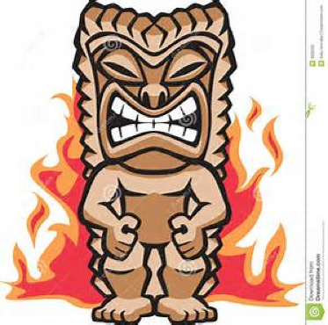
Hewahewa: Liholiho said burn all the tiki!

