Marshall Island Map Directions
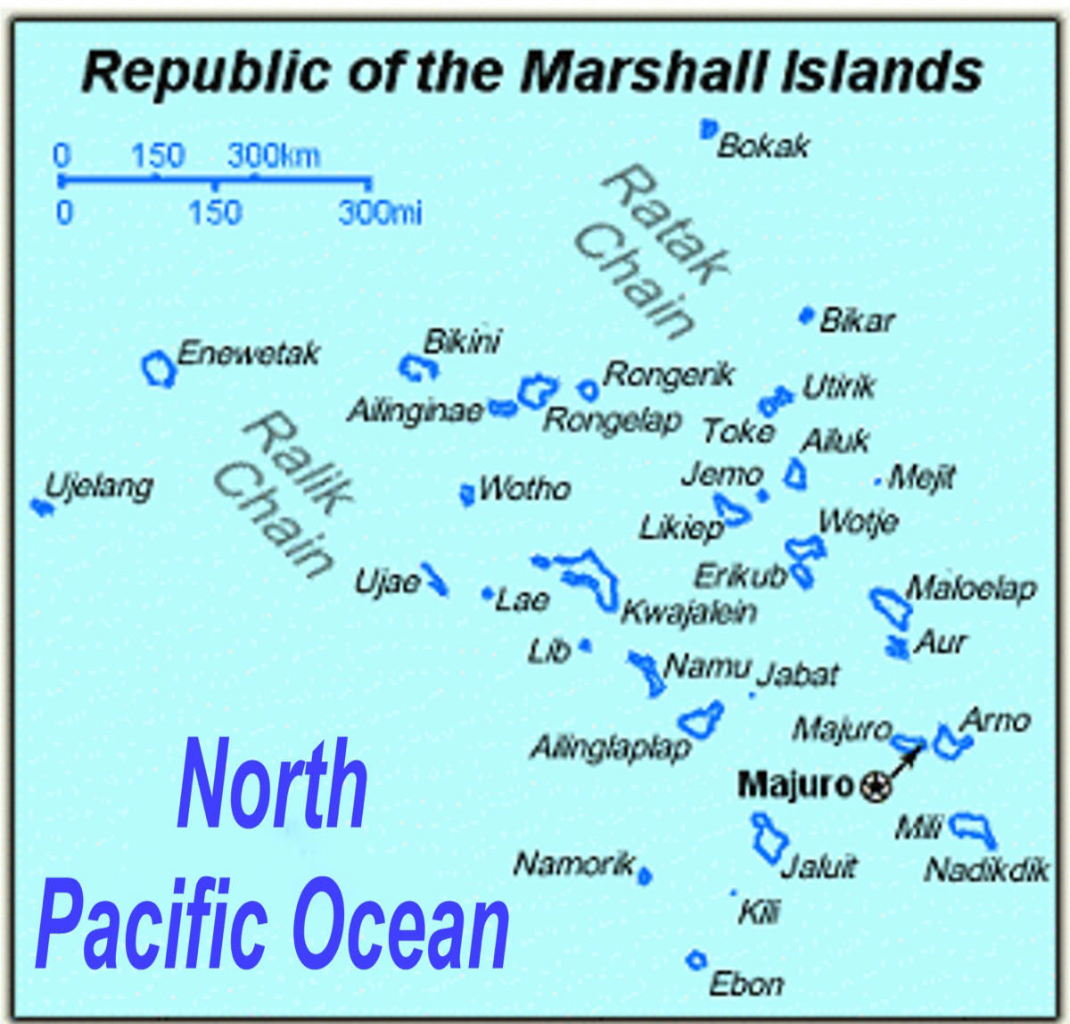
Use the Map above to label all of the following
Step 1: In the rectangle on our blank map write: The Republic of the Marshall Islands
Step 2:  Label the following:  Island Chains  Ratak/Sunrise Chain  Ralik/Sunset Chain  Pacific Ocean  Draw the following Key in the bottom left of your map  Key  Uninhabited Islands | Label the following uninhabited Islands  Ailinginae Atoll  Bikar (Bikaar) Atoll  Bikini Atoll  Bokak Atoll  Erikub Atoll  Jemo Island  lRongerik Atoll  Toke/Taka Atoll  Ujelang Atoll  After labelling the names of each of these uninhabited islands draw the following symbol next to each uninhabited island | Label the following inhabited Islands  Kwajalein Atoll  Majuro Atoll (capital)  Rongelap Atoll  Ailinglaplap Atoll  Arno Atoll  Jaluit Atoll  Mili Atoll  Color every island  Color the ocean blue

