Missionaries Vocabulary
Directions: For each term: define it, use it in a sentence and draw a picture that explains the term.
Palapala (p.82) Liholiho 1820 (p. 78)
Infanticide (p.79) Hiram Bingham (p.77)
Thaddeus (p.77) Asa Thurston (p.77) Opukahaia (p.77)

Example
word | definition | sentence | picture
Thaddeus | The ship the missionaries sailed on. | The Thaddeus sailed from Boston. | 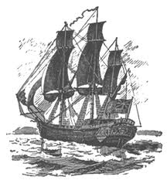

Missionaries Vocabulary
Directions: For each term: define it, use it in a sentence and draw a picture that explains the term.
Palapala (p.82) Liholiho 1820 (p. 78)
Infanticide (p.79) Hiram Bingham (p.77)
Thaddeus (p.77) Asa Thurston (p.77) Opukahaia (p.77)

Example
word | definition | sentence | picture
Thaddeus | The ship the missionaries sailed on. | The Thaddeus sailed from Boston.

