Monk Seal Double Puzzle
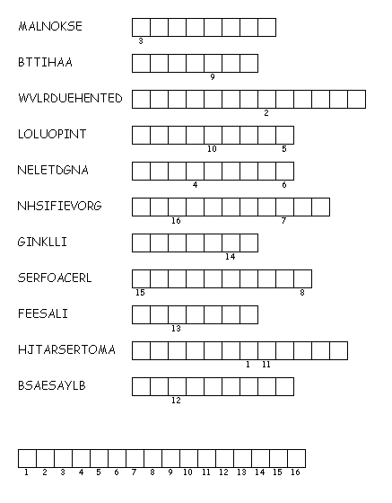

Directions: Unscramble each of the clue words.
Copy the letters in the numbered cells to other cells with the same number.

Hints:
1. Only found in Hawaii  2. Where monk seals live  3. The number left  4. Trash in the water  5. Caught in nets | 6. Catching to many  7. Happening on Kauai  8. Part of the habitat  9. Food  10. Main problems  11. Sharks eat

Secret word hint: People

