Monk Seal Letter Tiles Directions
Step one: Make 12 index card size pieces of paper
Step two: Write the following letters on them
Step Three: Unscramble the tiles to reveal a message.
Step four: Show your teacher when finished
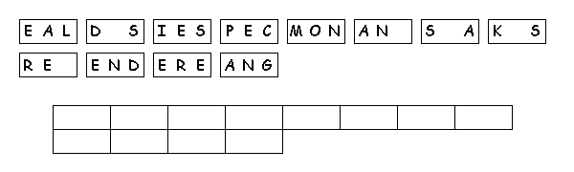

Monk Seal Letter Tiles Directions
Step one: Make 12 index card size pieces of paper
Step two: Write the following letters on them
Step Three: Unscramble the tiles to reveal a message.
Step four: Show your teacher when finished

