Unification Baseball/Pokemon Cards
Benchmark
3.1 – Explain the events (including warfare and land control) and people (including Kamehameha, Kekuhaupi’o, Kalani’opu’u, Kiwala’o, Keoua, Keawema’uhili, Kahekili, Kalanikupule, Davis, and Young) that led to the unification of the Hawaiian Islands
Directions:
Your task is to make baseball/Pokemon cards for the individuals involved in the story of the unification of the Hawaiian Islands.

Each card must include:
- The name of the Person
- A picture of the Person
- How that person or event contributed to the unification of the Hawaiian Islands.
- A chart that lists the years and important events in that persons life
- A power scale/ a point scale which shows that some individuals are more important or powerful than others 0 to 500…500 being the most powerful

Important People:
- Kamehameha
- Kaumuali’i
- Kahekili
- Kalanikupule
- John Young and Isaac Davis
- Keoua

Example card
John Young ___pts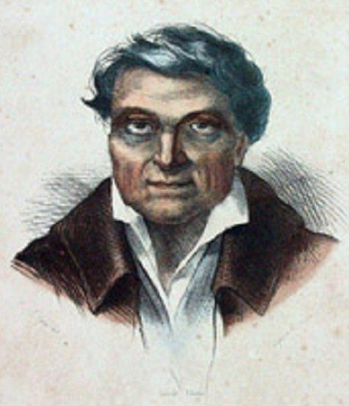 | John Young  (Write a paragraph here about John Young’s Role in the Unification of Hawaii)  Statistics  1790 Meets Kamehameha  1790 Becomes Kamehameha’s War advisor  1790-1802 Fights alongside Kamehameha in the wars for unification  1802 Becomes governor of Big Island

