Unification Landmarks Directions
Directions: Tell the story of the unification of Hawaii using photos of the following landmarks

-The Naha Stone
-HMS Resolution
-Kilauea Volcano
-1790 Footprints
-Puʻukoholā Heiau
-Iao Valley
-Nuuanu Pali Lookout

Example:

Landmark Explanation
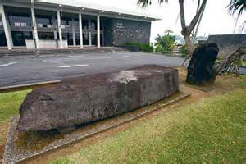 | In Old Hawaii it was believed that whoever moved the 7,000 pound Naha stone would unite the Hawaiian Islands and become Hawaii’s first King. At age 14 Kamehameha moved the stone and he would later unite the islands and become Hawaii’s first king.

