End of Kapu Digital Time Capsule Directions
Task: Your task is to identify ten artifacts that tell the story of how and why Liholiho ended the Kapu and what happened after he ended it.
You must have ten artifacts that go in the same order as the story (chronological order)
Each artifact must follow this format

Left side right side
Name of artifact  Image of artitact | Sentence that explains why the artifact is in the story (underline name of artifact and use the word because)

Example:

Matches  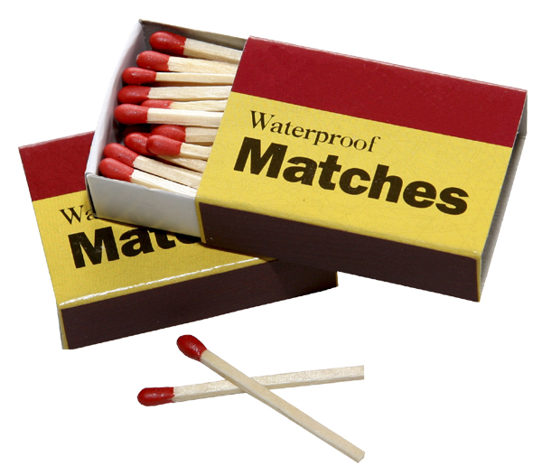 | Matches because Liholiho sent a message to his people that said burn the tiki

