End of Kapu Wheel directions
Step 1- draw a circle and separate it into 6 pieces
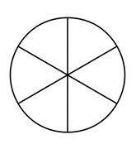

Step 2- label the 6 sections: Liholiho, Keopuolani, Ka’ahumanu, Hewahewa, Kekuaokalani, and Kapu System

Step 3- write two sentences to explain each term. For example: Liholiho was the second king of Hawaii. He was the king that ended the Kapu System.

End of Kapu Wheel directions
Step 1- draw a circle and separate it into 6 pieces

Step 2- label the 6 sections: Liholiho, Keopuolani, Ka’ahumanu, Hewahewa, Kekuaokalani, and Kapu System

Step 3- write two sentences to explain each term. For example: Liholiho was the second king of Hawaii. He was the king that ended the Kapu System.

