End of Kapu Booklet Directions:

Page 1 and 2 of the Booklet End of Kapu Wheel directions
Step 1- draw a circle and separate it into 6 pieces
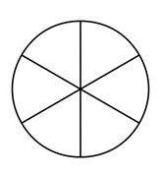

Step 2- label the 6 sections: Liholiho, Keopuolani, Ka’ahumanu, Hewahewa, Kekuaokalani, and Kapu System

Step 3- write two sentences to explain each term. For example: Liholiho was the second king of Hawaii. He was the king that ended the Kapu System.

Page 3 and 4 of the Booklet 1819 artifacts directions
Directions: draw and write an explanation for each of your ten artifacts (place 5 on each page)
A banquet invitation because Liholiho ended the Kapu at a banquet.  Page 4 | Pork because women were not allowed to eat pork.  Page 5

Step 4 Page 5 and 6 attach your “TruLife Liholiho” Essay. The essay must follow the pre-write, contain intro and concluding sentences in each of the three paragraphs, use transition words, and all 10 artifacts must be drawn and colored within the essay. See example below:

Liholiho was the 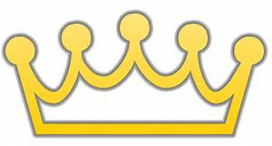that ended the Kapu.

