Mahele The A’s B’s and Cs of the Mahele
Directions:
Find one fact for each letter of the alphabet about the Mahele. Find an image that depicts the fact and write explain the fact under the image.

Example: Notice this example is about Mesopotamia so you can’t copy it

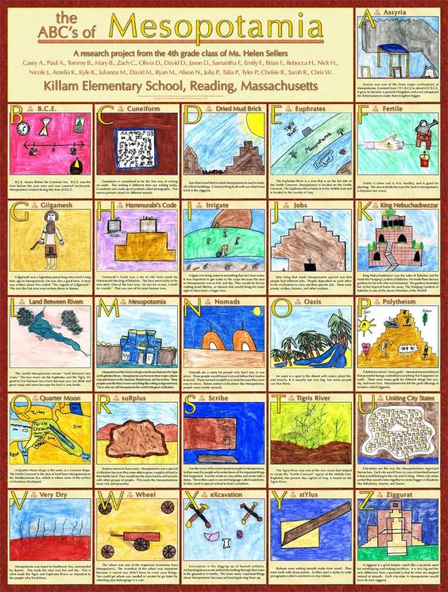

ABC’s of Mahele

