Free Association Fishbone
Directions: Create a fishbone diagram of the good and bad aspects of the Free Association Compact between the USA and the Marshall Islands. For each section write a main point, a quote from the readings, and tie the quote to your main point!
You will need 3 reasons free association is good and 3 reasons free association is bad. For each reason state the reason, give a quote, and tie the quote to the reason.

Draw yours like this: (this is an example of appearance only the info is incorrect)
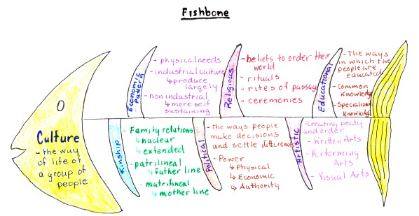

Free Association Fishbone
Directions: Create a fishbone diagram of the good and bad aspects of the Free Association Compact between the USA and the Marshall Islands. For each section write a main point, a quote from the readings, and tie the quote to your main point!
You will need 3 reasons free association is good and 3 reasons free association is bad. For each reason state the reason, give a quote, and tie the quote to the reason.

Draw yours like this: (this is an example of appearance only the info is incorrect)

