The Missionaries 1820-1854
The first Christian missionaries arrived in Hawaii in 1820 when Liholiho was king. Before the missionaries arrived Hawaiians had their own educational system based on practical needs. Four things Hawaiians were taught were navigation, warfare, legends, and craft making.  Once the missionaries arrived they began to develop modern education in Hawaii. The work of missionaries in developing education can be divided into two periods:  1. From 1820 to 1831 they created the Hawaiian alphabet and the Hawaiian language was written down. Textbooks were written and adults learned reading and writing.  2. From 1831 to 1840 teachers were trained and schools were built.  On the island of Kauai chief Kaumuai’i helped the missionaries start a school in Waimea. Kaumuai’i was the first student enrolled. | 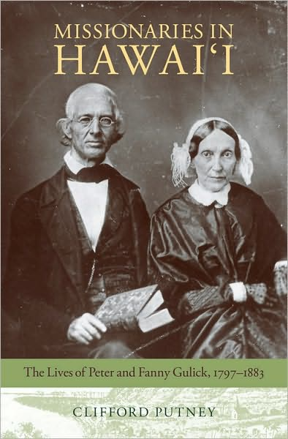

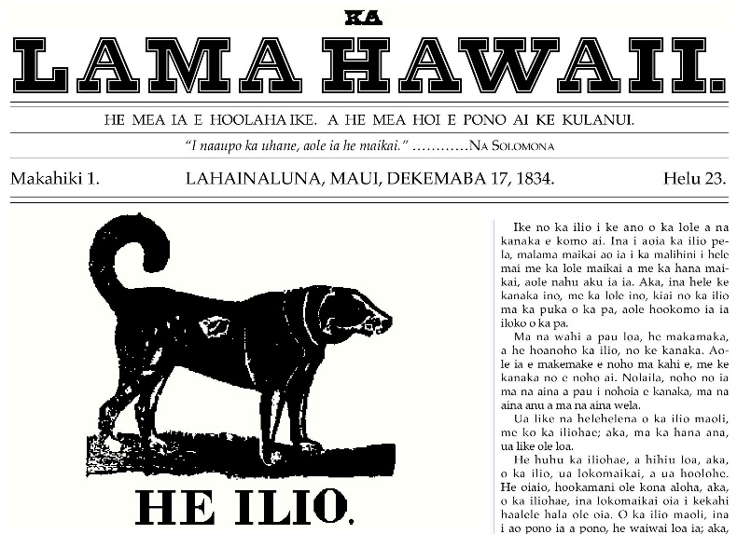 | In 1824 Ka’ahumanu issued a proclamation saying that “All Hawaiians must learn the palapala”. (Palapala means alphabet)  Students can make history, too: The first newspaper printed in Hawaii was a student newspaper, Ka Lama Hawaii (The Hawaiian Luminary), produced Feb. 14, 1834 at Lahainaluna High School on Maui.  Hawaii’s first English language newspaper was made in 1836 it was called the Sandwich Island Gazette.

