Missionaries Crossword
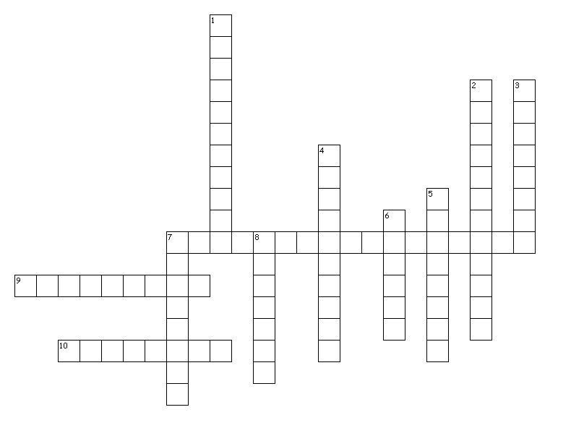

Across Down
7. Nice houses were called _________________________  9. This boy is considered the first Hawaiian Christian  ____________________________ .  10. The name of the king when the missionaries arrived in Hawaii was __________________________________. | 1. The custom of killing babies _______________________  2. Leader of the missionaries ________________________  3. The name of the missionaries boat __________________  4. They wanted to cover the islands with these  ______________________________.  5. Hawaiian word for alphabet _______________________  6. Kuamuali’I’s son ________________________.  7. One of the three ways they spread their message  _________________________________  8. Missionaries created these learning institutions  _____________________.

