Missionaries Impact on Hawaii Interactive Poster
Directions: use the artifacts in this Hawaii Museum Collection Poster to explain how the missionaries impacted Hawaii

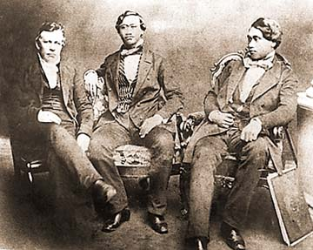  Missionary pioneer Dr. Gerrit Judd, left, on an 1849 with Prince Alexander Liholiho and Prince Lot Kamehameha, right. | 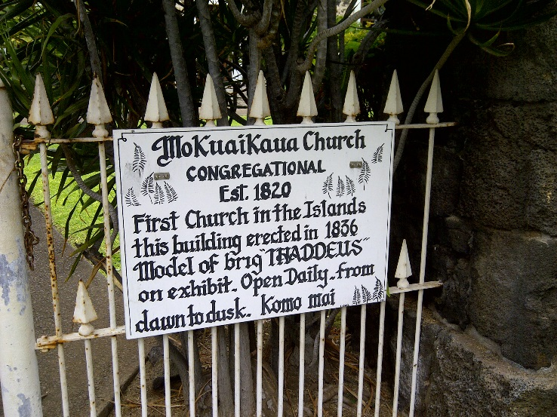  Sign on gate of Hawaii’s first church
The original Lahainaluna High School sign | 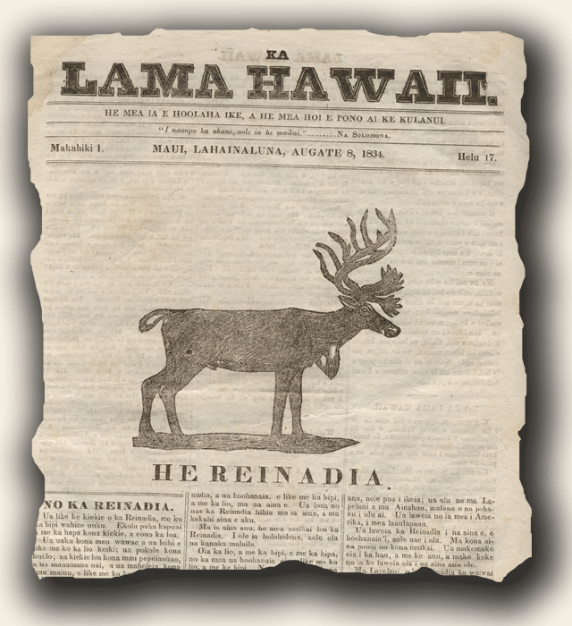  Ka Lama Newspaper 1834
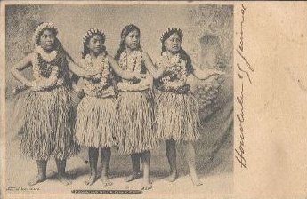  Hawaiian Hula Photo from 1800s | 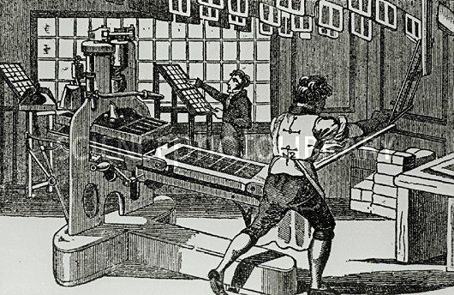  1800s Printing Press
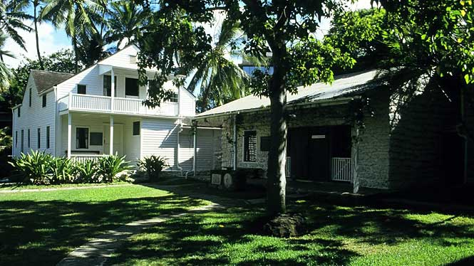

Oldest surviving Missionary Houses in Hawaii located at the Mission Houses Museum in Honolulu

An assortment of Missionaries Tools

