Missionaries Suitcase Project
Directions: You are a missionary sailing to Hawaii in 1820 use what we have learned to pack a suitcase with the 10 most important items necessary to complete the mission
For each item you will need name of item, picture of item and why that item is important

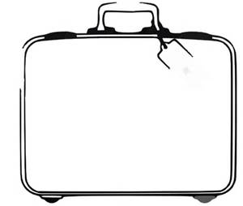

My Missionary Suitcase
Item | Explanation
A Printing Press  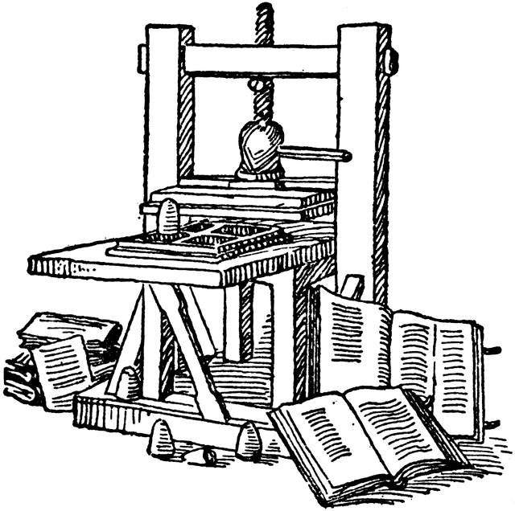 | A Printing Press because missionaries printed Hawaii’s first books and newspapers

