Moriori Crosword
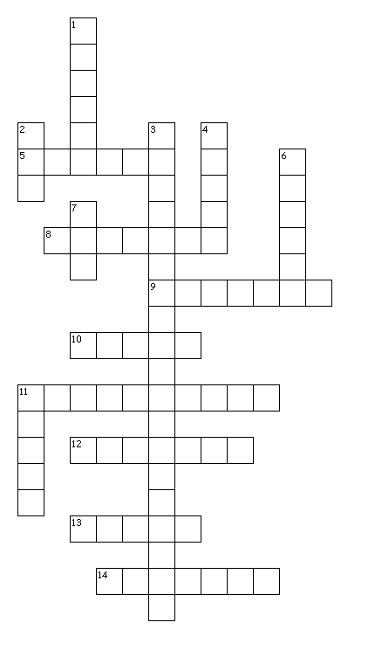
Across  5. The name of the peaceful way of life  8. Maori were...  9. The number one economic activity  10. Land with water on three sides  11. Type of footprint  12. Name of their island  13. Culture from New Zealand  14. Culture from Chatham Island | Down  1. Trash pile  2. Number of social classes  3. Moriori were...  4. They used these instead of canoes  6. Seventeen percent of the island  7. Water with land on three sides  11. Type of society

