The Moriori - an ancient Polynesian Peaceful Culture on Chatham Island
Settlement
Moriori villages on Chatham Island were primarily Coastal Villages. The largest three villages were located near bays. Villagers used a coastal hunting life-style but moved in small parties to resource zones like mountains, hills, lakes, and rivers where specific food resources were hunted or gathered. Examples: Waitangi Village near Petre Bay, Owenga Village near Hansen Bay and Te Ono Village located between Petre Bay and Lake Huro (see map).

Social Structure
Moriori Society had an egalitarian(equal) social structure which meant everyone was on the same social level. Everyone participated in subsistence/survival tasks and all work was divided by age and gender rather than by rank/class. Laws and religious beliefs were observed strictly by all Moriori because there was a supernatural regulation of hunting, fishing, and gathering activity which meant that the gods and nature led and controlled society. Violations of resource rights were punished by supernatural forces not the arbitrary power of a chief. The most remarkable piece of evidence for the egalitarian structure of Moriori culture is the evident lack of warfare. The Moriori declared themselves to have been a peaceful people who did not resort to violence in pre-European times. They called their peaceful way of life “Nunuku” after an early leader, Nunuku, organised a permanent truce and forbade “man-killing”.

Economic Activities
Moriori were low technology hunters and gatherers. A high human population density was sustained in a small area because there was an abundance of natural resources mostly marine resources(resources from the ocean). The abundance of resources was unaffected by the actions of man, which means that Moriori had a low impact on the environment. In today’s terms we could say that the Moriori had a small ecological footprint, a sustainable culture, and were environmentally friendly. Moriori had a “Survival economy” their daily tasks were focused on survival. Their economic activities in order of importance were: sealing; capturing albatross and penguins; fishing; shellfish gathering, hunting birds and gathering plant foods. Most food came from netting off rocky shores. Moriori also trapped eels, snared birds and hunted seals, which they used for food and made clothing from their skins. Most fishing was shore based and specialized in the use of nets.

Flora
Moriori had few vegetables, the kopi (karaka) tree, which was used for fruit.
80% of the main island was covered with ferns, swamp grasses, and a thick canopy of long thin- shrubs which along with Karaka trees were used for shelters, fires, and tools.

Tools
Wooden Albatross Waadi (Wood Clubs) or Whale Bone Patu (Whale Bone Clubs)-clubs were used for killing animals such as penguins and albatross
Kelp Bags-Bags made from kelp were used for carrying bodies of penguins and albatross
Wood baskets-used for carrying land birds
Fiber Nets-for fishing
Wood Spears-for spear fishing (not used for war)
Adzes-stone hammer like tools for carving and cutting down trees
Mataa or blubber knives used for skinning seals
flake tools(stone age stone tools) used for carving, cutting, and cooking
Toggle Harpoon –for hunting seals
Waka Korari (rafts) made from a base of kelp and sides of bound reeds. They were not traditional Polynesian canoes. These rafts were developed to catch albatross, penguins, and seals because they could land on difficult shores where these animals lived. These rafts were not voyaging technology.

Middens
Moriori had their own waste management system called middens. Middens were refuse heaps, sites where waste was dumped similar to landfills of today. Anthropologist have found several seal middens (refuse heaps of seal bones) approximately 300 yards from the coast and several miles from the closest river/drinking water source.
Map
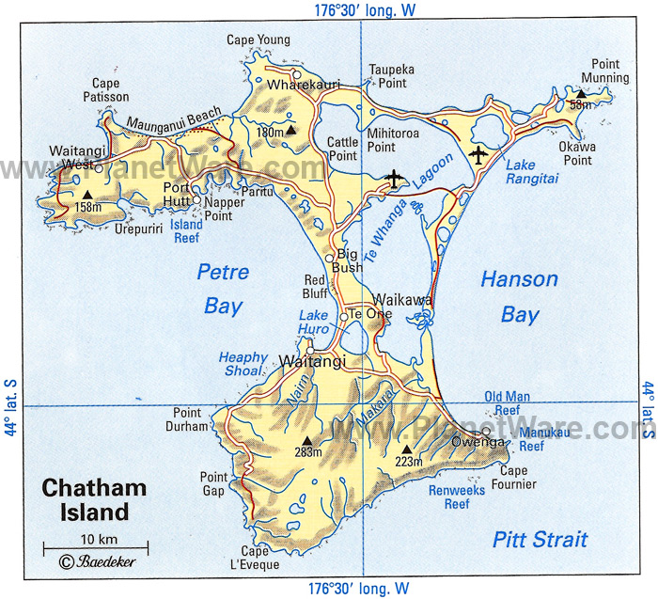
Moriori Raft Toggle harpoon
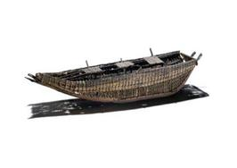 | 