Old Hawaii Crossword
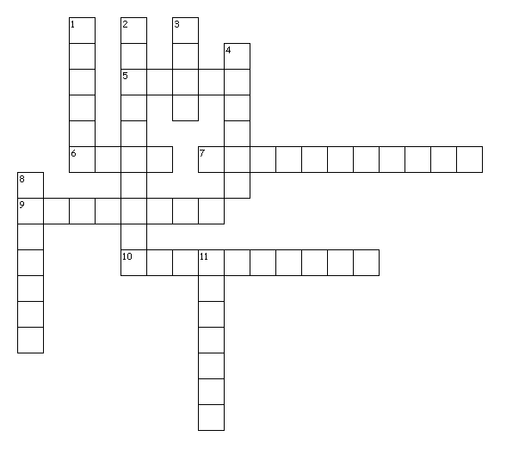
1. _____________ were the priests DOWN
2. ________________________ were the common people
3. There were _________________levels in old Hawaii
4. A kauwa might have a ____________________on his face
8. Kahuna were also _______________________________.
11. Alii sometimes wore _____________________.

5. _______________ were kapu breakers ACROSS
6. The ________________ were the ruling class
7. A person's level in society is their ______________________________.
9. Kauwa had to live as _______________________.
10. Kahuna designed houses just like _____________________________

