Old Hawaii Social Class Pyramid Directions
Step one: Title the paper and draw a pyramid with four sections
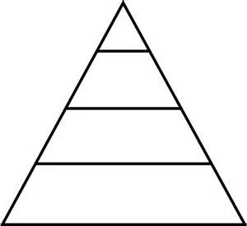

Step Two: Label the four sections
Ali’i, Kahuna, Maka’ainana, Kauwa

Step Three: Draw and label pictures that show who each group is and what they do
Example:
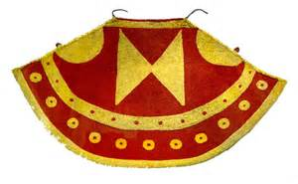
Wore Symbols of Royalty

Requirements:
Ali’i 2 pictures and captions
Kahuna 3 pictures and captions
Maka’ainana 4 pictures and captions
Kauwa 3 pictures and captions

Step four: Color each section a different color (rainbow it)

