Kauai Tsunami
On April 1, 1946, a tsunami struck the island of Kauai. Two powerful waves hit Kauai beginning about 6:30 a.m. In their wake, 14 people died, 3 were missing- and 7 were hospitalized for injuries. Nine of the dead were small children.
Nearly every dwelling in the makai areas of Ha‘ena, Kalihikai, Kalihiwai, Moloa‘a and Wainiha were totally destroyed. Anahola, Wailua and Nawiliwili were also hit hard.
At Ha‘ena, 17 homes were completely destroyed. Kalihiwai saw homes and stores swept inland and thrown against the pali. To the south at Moloa‘a, a wall of water surged about one-half mile inland wiping out all of Moloa‘a’s nine houses.
Down in Nawiliwili, waves smashed a number of business buildings. Across the way at Kalapaki, Mrs. Charles Rice and her infant son, Robin, were at home when she was warned of the tsunami by Charles Hada, the Rice’s yardman.
When the second wave hit, the house buckled and Rice found herself swimming while holding onto her son. At another point, she recalled placing him on a floating tree trunk. Later, she held on to a branch for dear life.

*Local Note- Rice family = Rice street in Lihue,,,Lights on Rice Parade

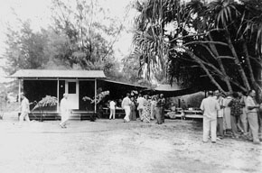
The Rice home before the tsunami
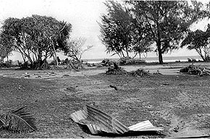
The Rice home after the tsunami

The 1957 Tsunami
In 1957. Another tsunami hit Kauai. 75 homes were demolished or damaged along the 15 mile strip between Kalihiwai and Ha‘ena--including 25 of 29homes at Ha‘ena -- leaving around 250 persons homeless. Six Kaua‘i bridges were washed out, including the bridge at Kalihiwai, isolating 1,000 persons on the Ha‘ena end of the road. Fortunately, no deaths or injuries resulted from this event.

Out of 29 homes that once stood at Haena, only four can now be lived in. A YMCA boys' camp, recently repaired from 1946 tidal wave damage, was washed out to sea.

Authorities said it was miraculous that there were no injuries or deaths on the neighbor islands, especially Kauai where it was almost by chance that residents of Hanalei and Haena got warning of the approaching disaster.
The Hanalei Civil Air Patrol squadron sounded the alarm throughout the Hanalei Valley and saw that every single resident took refuge to high ground.

