Unification Crossword
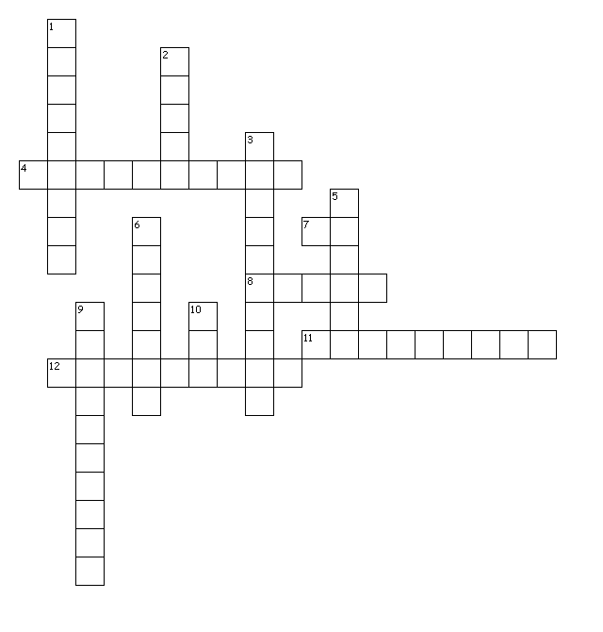
Questions:
Across  4. Hawaii's first king  7. The war god  8. used to kill Keoua  11. Name of famous heiau  12. Kamehameha's war advisor | Down  1. saved Kauai from death and war  2. Enemy on Maui  3. symbol of peace  5. Hawaii's most famous Battle  6. naval battle  9. Kamehameha's wife  10. Valley Battle with blood in the water

