Unification who’s who? Keoua of the Flaming Cloak
Keoua of the Flaming Cloak was Kamehameha’s greatest enemy on Big Island. After fighting Kamehameha’s army to a tie at a battle in Hilo Keoua sent his army home to Ka’u. As his army entered the domain of the unpredictable goddess Pele the volcano erupted. Before Keoua and his men could make their way out of danger a terrible eruption trapped them, throwing a cloud of scorching, suffocating smoke across the sun and raining hot sand and cinders on their bare backs. One third of Keoua’s army was destroyed. Today his armies’ footprints can still be seen at Keonehelelei “the area of falling sands”. The Footprints are called “The 1790 Footprints”! | 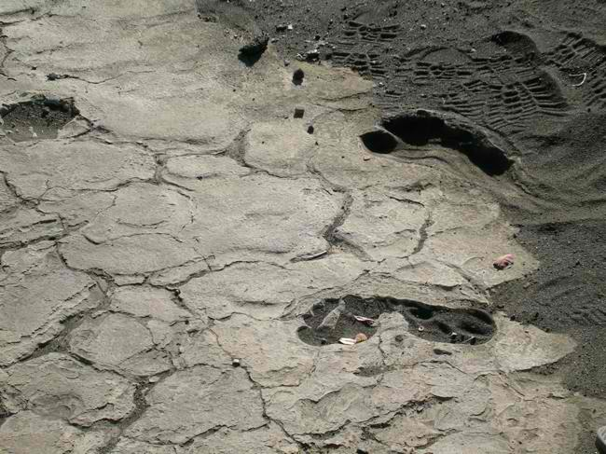  “The 1790 Footprints” the volcanic ash fossilized Keoua’s warriors footprints
Kahekili “the Thunderer”
Kahekili was Kamehameha’s greatest enemy on Maui. He was called "The Thunderer." Kahekili had taken his name from a thunder god, and as a reminder of this he tattooed one side of his body black from head to toe so they called him "pahupu" or "cut-in-two" warrior. The seven-foot “Thunderer,” was a thrill seeker. Kahekili loved the sport of lelekawa, cliff diving. He dove from 400 foot high Maui cliffs and was called “King of the Spirit Leap”. Kahekili was one of the fiercest warriors in Hawaii. After a few Oahu chiefs called him “The Forgetful King” he roasted them, built a home from their bones, and made their skulls “memory symbols.” Kamehameha fought Kahekili’s armies at the famous Battle of Iao Valley, during the battle the river turned crimson red from blood. Unable to defeat “The Thunderer” Kamehameha sent Kahekili two stones--one black and one white. Kahekili knew the stones were a choice: the white stone stood for peace and the black stone meant war.
Kahekili chose the white stone and told Kamehameha that he could have Maui after he died. Kahekili died in 1794 and Kamehameha took control of Maui.

Kalanikupule “the heavenly prayer of KU”
Kalanikupule was Kahekili’s eldest son, he was Kamehameha’s greatest enemy on Oahu. In 1795, Kamehameha and his army invaded Oahu, arriving with a fleet of war canoes at Waikiki Beach. Kamehameha fought Kalanikupule in the most famous battle in Hawaiian History, The Battle of Nuuanu. The six mile battle ended after Kamehameha forced Kalanikupule’s men off the 1,2000 foot high cliff known today as “ the Pali Lookout”. The name of the battle in Hawaiian is Kaleleakeanae," the leaping fish”. Although most say 400 soldiers went off the cliff , in 1897, while building the Pali Highway excavators found approximately 800 skulls, so, today we think 800-plus people lost their lives going over, either jumping, in battle or just trying to escape. | 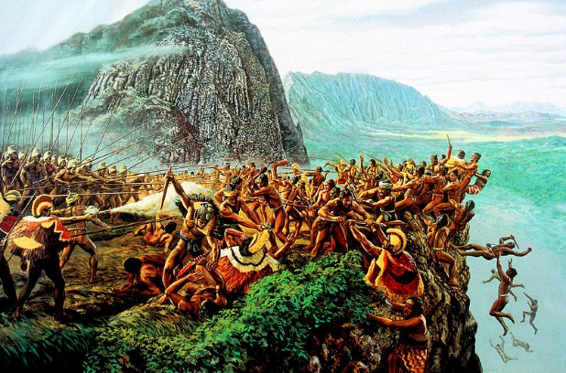  In 1897, while building the Pali Highway excavators found approximately 800 skulls
Kaumuali’i “the nourisher of his people”
Kaumualili was named “the oven of the nobility,” by his mom Chiefess Kamkahelei. She named him this because she believed he would become “the means of nourishment” of Kauai’s people. Not only did he nourish his people but he saved them from death and war. Kamehameha had just taken control of Oahu and was aiming to conquer Kaua’i by force. Kamehameha sailed with his men in canoes toward Kaua’i, but got caught in a storm while crossing the channel from O’ahu. So he and his men were forced to turn back. Undeterred, Kamehameha built up his already large sea army. Kaumuali’I realized that he could not win against Kamehameha’s sea army of 1200 canoes and 10,000 warriors so in order to protect his people from death and war he surrendered Kaua’i to Kamehameha. Grateful of the gesture, Kamehameha allowed Kaumuali’i to be governor of Kaua’i. The nourisher of the people had saved Kaua’i lives!

